ADVANCED EXCEL PROJECT REPORT
Loan Portfolio Profitability & Risk Analytics
Understanding where the business is losing money and what management can do about it
Project Information | Details
Student Name | Tufan Bera
AF Code | AF05308340
Project Title | Loan Business Profitability Analysis
Project Duration | 4 Days
Trainer Name | Sayan Sau
Submission Date | 29-08-2026
GitHub Username
GitHub Repository Link

At a glance
The portfolio is currently loss-making by about ₹36.05 lakh. The main issue is concentrated in Car loans. The charts show that lower pricing and longer tenures are closely connected with the loss, while the regional view shows that every region is also operating at a loss. The focus of the analysis is therefore to identify where the bank can improve loan economics rather than simply increase loan volume.

Project Objective
The aim of this project is to look at the loan portfolio from a business point of view. Instead of only reporting totals, the analysis asks where the bank is making money, where it is losing money, what is causing the loss, and which changes are most likely to improve profitability.

Tools & Technologies Used
- Microsoft Excel
- Excel formulas and calculated fields
- PivotTables and PivotCharts
- Slicers for interactive analysis
- Excel dashboard
- Microsoft Word

Dataset Description
The dataset contains 500 loan records covering Car, Bike, Laptop and Mobile Phone products. The analysis uses loan amount, interest rate, tenure, loan status, region, revenue, cost of funds, default loss and net bank profit. The data is also grouped into interest-rate, tenure and loan-size segments to make the business analysis easier.

Key Features
- Portfolio-level profitability KPIs
- Product profitability comparison
- Interest-rate and pricing analysis
- Product × interest-rate comparison
- Product × tenure comparison
- Regional profitability analysis
- Interactive slicers for product, region, status, rate and tenure
- Five decision-focused visuals

1. What is happening to the business?
The first result is clear: the portfolio is not profitable. There are 500 loans with principal of about ₹12.74 crore. Revenue is around ₹3.32 crore, while total cost is around ₹3.68 crore. This leaves the business with a net loss of about ₹36.05 lakh and a profit margin of −2.83%.
Metric | Current Result | What it means
Total loans | 500 | Size of the portfolio
Loan principal | ₹12.74 Cr | Money currently deployed
Total revenue | ₹3.32 Cr | Income generated
Cost of funds | ₹3.52 Cr | Funding cost is higher than revenue
Default loss | ₹15.86 Lakh | Additional loss from defaults
Net bank profit | −₹36.05 Lakh | Portfolio is loss-making
Profit margin | −2.83% | Return on the loan book is negative
Business meaning
Recovering defaults is important, but it is not enough to solve the problem. Cost of funds is already higher than total revenue. The bank therefore needs to improve the terms and mix of the loans themselves.

2. Product profitability — where is the money being lost?
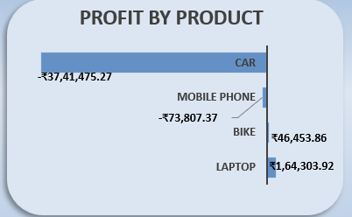
Figure 1: Profit by Product
What the chart shows: Car is the clear problem. It loses about ₹37.41 lakh, while Laptop earns about ₹1.64 lakh and Bike earns about ₹0.46 lakh. Mobile Phone is only slightly negative.
Impact on the business: Car is large enough to cancel out the profit coming from the other products. Simply increasing the number of Car loans under the same conditions would make the situation worse.
What management should do: Review Car loans as a separate business segment. Before stopping the product, look at the rate, tenure and loan-size combinations inside Car lending. At the same time, protect the profitable Laptop and Bike segments.

3. Interest rate — are we charging enough?
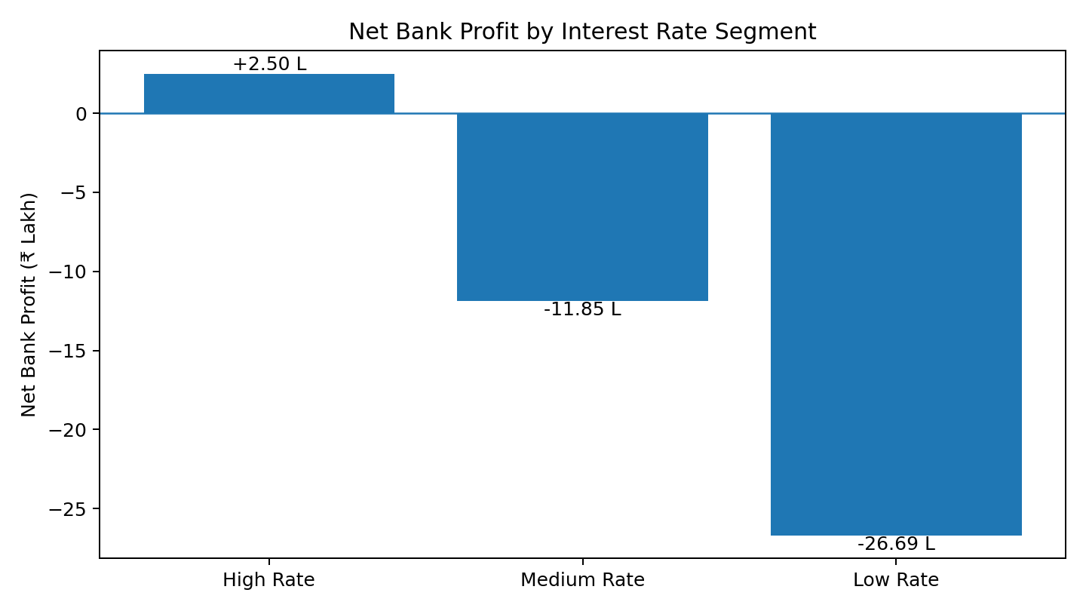
Figure 2: Net Bank Profit by Interest Rate Segment
What the chart shows: High Rate generates about ₹2.50 lakh of profit. Medium Rate loses about ₹11.85 lakh, while Low Rate loses about ₹26.69 lakh.
Impact on the business: The lower-priced loans are not generating enough return to cover the cost of funding and other costs. This is a warning that the current pricing structure is too weak in parts of the portfolio.
What management should do: Set a practical minimum pricing level based on funding cost and expected loss. The first review should be on Low Rate loans, especially Car loans. The goal is not to increase every customer's rate, but to stop approving loans that do not make economic sense.

4. Product × Interest Rate — where is the pricing problem?
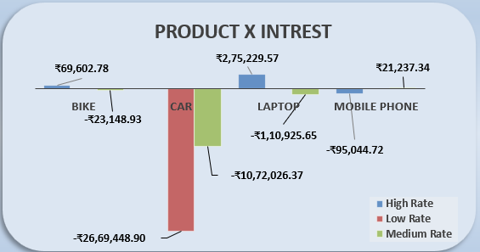
Figure 3: Product-wise Profitability by Interest Rate
What the chart shows: The biggest negative combination is Car + Low Rate at about ₹26.69 lakh of loss. Car + Medium Rate adds another roughly ₹10.72 lakh of loss. Other products are much smaller by comparison.
Impact on the business: This is more useful than looking at the overall rate chart because it tells management where the problem actually sits. A blanket rate increase would be unnecessary for products that are already profitable.
What management should do: Target the Car rate structure first. Low- and Medium-rate Car loans should be repriced or approved under stricter rules. Any new pricing rule should be checked against customer demand and expected risk before being applied widely.

5. Product × Tenure — is the loan running for too long?
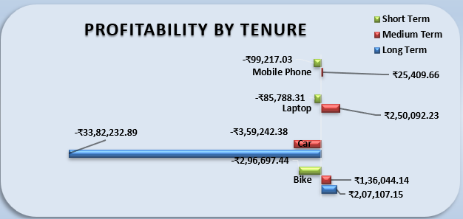
Figure 4: Profitability by Tenure
What the chart shows: Long-term Car lending is the biggest negative combination, at about ₹33.82 lakh of loss. Car Medium Term is also negative, while Bike and Laptop have positive medium/long-term contributions in the chart.
Impact on the business: A longer tenure keeps the bank's money committed for more time. If the interest rate is not high enough, the cost of carrying the loan can consume the return. The chart suggests this is a major part of the Car problem.
What management should do: Review the maximum tenure allowed for Car loans. A shorter tenure or an additional rate for longer-tenure loans would target the problem without changing the policy for every product.

6. Regional profitability — where is the business losing money?
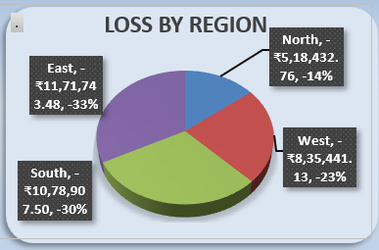
Figure 5: Regional Profitability / Loss by Region
What the chart actually shows: This chart is based on Net Bank Profit by Region, not Default Loss. East has the largest regional loss at about ₹11.71 lakh, followed by South at ₹10.79 lakh, West at ₹8.35 lakh and North at ₹5.18 lakh.
Impact on the business: All four regions are loss-making. This means the problem is not limited to one geography. East is the biggest regional loss contributor, but the regional result points to a broader profitability issue in the loan portfolio.
What management should do: Do not solve the problem by simply withdrawing from one region. First compare the product, rate and tenure mix inside each region. East should receive the closest review because it has the largest loss, but the pricing and product rules should be improved across the portfolio.
Important correction
The visual supplied for the regional section is a Net Bank Profit by Region chart. It should therefore be described as regional profitability/loss, not default loss. If you want the report to analyse Default Loss by Region, the chart itself needs to be replaced with the Default Loss PivotChart.

7. What the five charts tell us together
When the five charts are read together, a consistent picture appears. Car is the main product-level problem. Low-rate lending is the largest rate-level problem, and the product-rate chart shows that much of this loss sits inside Car. The tenure chart then shows that long-term Car loans are particularly damaging. The regional chart shows that losses exist across every region, so the business should fix the loan economics rather than treat the issue as a single-region problem.
Finding | Business meaning | Action
Car: −₹37.41 Lakh | Largest product loss | Review Car lending rules
Low Rate: −₹26.69 Lakh | Pricing is not covering costs | Review pricing floor
Car + Low Rate: −₹26.69 Lakh | Largest product-rate loss | Reprice or tighten approval
Car + Long Term: −₹33.82 Lakh | Long duration is hurting returns | Review maximum tenure
East: −₹11.71 Lakh | Largest regional loss | Review East product/rate mix
Laptop: +₹1.64 Lakh | Currently profitable | Consider controlled growth
Bike: +₹0.46 Lakh | Currently profitable | Maintain/selectively grow

8. Recommended Business Actions
First — Fix Car economics: Review pricing, tenure and loan-size rules for Car loans before expanding the segment.
Second — Review low-rate lending: Set a minimum acceptable return after funding cost and expected loss.
Third — Control long-term Car loans: Consider shorter maximum tenure or additional pricing for longer terms.
Fourth — Control very-large exposures: Use stronger approval and exposure limits where loan size creates concentrated losses.
Fifth — Protect profitable products: Study whether Laptop and Bike can be expanded without changing their current economics.
Sixth — Review regional mix: Start with East because it has the largest regional loss, but compare the product/rate mix before making a geographic decision.

9. Dashboard Structure
The dashboard should remain simple. The top section should show the main KPIs, followed by the same five visuals used in this report. The slicers should allow management to filter Product, Region, Loan Status, Interest Rate Segment and Tenure Segment.
Visual | Chart Type | Business question
Net Bank Profit by Product | Horizontal Bar | Which product is hurting profitability?
Net Bank Profit by Interest Rate Segment | Column | Are current rates producing enough return?
Product-wise Profitability by Interest Rate | Clustered Column | Which product-rate combination is causing the loss?
Product-wise Profitability by Tenure | Clustered Bar | Is loan duration affecting profitability?
Regional Profitability / Loss | Pie / regional chart supplied | Which region has the largest loss?

10. Learning Outcome
This project shows how Excel can be used to move from raw loan records to a business decision. The important part is not simply creating PivotTables or charts. Each visual is used to answer a business question and decide what should be changed.

11. Conclusion
The portfolio is currently loss-making, but the loss is concentrated enough to give management a clear starting point. Car loans are the main source of the problem, particularly when the loans are priced at lower rates and run for longer periods. The regional chart shows that the loss is present across all regions, so the solution should focus on improving loan economics rather than withdrawing from a single geography.
Final takeaway
The business should not focus only on increasing the number of loans. It should focus on making sure each loan generates enough return after funding cost and other losses. For this portfolio, fixing Car-loan pricing and tenure is the most important first step.

